What is Web Service
A Web Service is can be defined by following ways:
- It is a client-server application or application component for communication.
- The method of communication between two devices over the network.
- It is a software system for the interoperable machine to machine communication.
- It is a collection of standards or protocols for exchanging information between two devices or application.
Let's understand it by the figure given below:
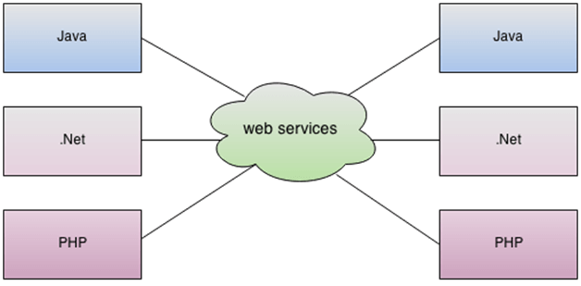
As you can see in the figure, Java, .net, and PHP applications can communicate with other applications through web service over the network. For example, the Java application can interact with Java, .Net, and PHP applications. So web service is a language independent way of communication.

Types of Web Services
There are mainly two types of web services.
- SOAP web services.
- RESTful web services.
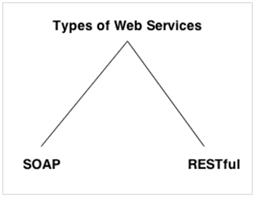

Web Service Features

XML-Based
Web services use XML at data description and data transportation layers. Using XML exclude any networking, operating system, or platform binding. Web services-based operation is extremely interoperable at their core level.

Loosely Coupled
A client of a web service is not fixed to the web service directly. The web service interface can support innovation over time without negotiating the client's ability to communicate with the service. A tightly coupled system means that the client and server logic are closely tied to one another, indicating that if one interface changes, then another must be updated. Accepting a loosely coupled architecture tends to make software systems more manageable and allows more straightforward integration between various systems.

Coarse-Grained
Object-oriented technologies such as Java expose their functions through individual methods. A specific process is too fine an operation to provide any suitable capability at a corporate level. Building a Java program from scratch needed the creation of various fine-grained functions that are then collected into a coarse-grained role that is consumed by either a client or another service.
Businesses and the interfaces that they prove should be coarse-grained. Web services technology implement a natural method of defining coarse-grained services that approach the right amount of business logic.

Ability to be Synchronous or Asynchronous
Synchronicity specifies the binding of the client to the execution of the function. In synchronous invocations, the client blocks and delays in completing its service before continuing. Asynchronous operations grant a client to invoke a task and then execute other functions.
Asynchronous clients fetch their result at a later point in time, while synchronous clients receive their effect when the service has completed. Asynchronous capability is an essential method in enabling loosely coupled systems.

Supports Remote Procedure Calls (RPCs)
Web services allow consumers to invoke procedures, functions, and methods on remote objects using an XML-based protocol. Remote systems expose input and output framework that a web service must support.
Component development through Enterprise JavaBeans (EJBs) and .NET Components has more become a part of architectures and enterprise deployments over a previous couple of years. Both technologies are assigned and accessible through a variety of RPC mechanisms.
A web function supports RPC by providing services of its own, equivalent to those of a traditional role, or by translating incoming invocations into an invocation of an EJB or a .NET component.

Supports Document Exchange
One of the essential benefits of XML is its generic way of representing not only data but also complex documents. These documents can be as simple as describing a current address, or they can be as involved as defining an entire book or Request for Quotation (RFQ). Web services support the transparent transfer of documents to facilitate business integration.

Web Service Components
There are three major web service components.
- SOAP
- WSDL
- UDDI

SOAP
SOAP is an acronym for Simple Object Access Protocol.
SOAP is a XML-based protocol for accessing web services.
SOAP is a W3C recommendation for communication between applications.
SOAP is XML based, so it is platform independent and language independent. In other words, it can be used with Java, .Net or PHP language on any platform.

WSDL
WSDL is an acronym for Web Services Description Language.
WSDL is a xml document containing information about web services such as method name, method parameter and how to access it.
WSDL is a part of UDDI. It acts as a interface between web service applications.
WSDL is pronounced as wiz-dull.

UDDI
UDDI is an acronym for Universal Description, Discovery and Integration.
UDDI is a XML based framework for describing, discovering and integrating web services.
UDDI is a directory of web service interfaces described by WSDL, containing information about web services.

SOAP Web Services
SOAP stands for Simple Object Access Protocol. It is a XML-based protocol for accessing web services.
SOAP is a W3C recommendation for communication between two applications.
SOAP is XML based protocol. It is platform independent and language independent. By using SOAP, you will be able to interact with other programming language applications.

Advantages of Soap Web Services
WS Security: SOAP defines its own security known as WS Security.
Language and Platform independent: SOAP web services can be written in any programming language and executed in any platform.

Disadvantages of Soap Web Services
Slow: SOAP uses XML format that must be parsed to be read. It defines many standards that must be followed while developing the SOAP applications. So it is slow and consumes more bandwidth and resource.
WSDL dependent: SOAP uses WSDL and doesn't have any other mechanism to discover the service.

RESTful Web Services
REST stands for REpresentational State Transfer.
REST is an architectural style not a protocol.

Advantages of RESTful Web Services
Fast: RESTful Web Services are fast because there is no strict specification like SOAP. It consumes less bandwidth and resource.
Language and Platform independent: RESTful web services can be written in any programming language and executed in any platform.
Can use SOAP: RESTful web services can use SOAP web services as the implementation.
Permits different data format: RESTful web service permits different data format such as Plain Text, HTML, XML and JSON.

SOAP vs REST Web Services
There are many differences between SOAP and REST web services. The important 10 differences between SOAP and REST are given below:
No. | SOAP | REST
1) | SOAP is a protocol. | REST is an architectural style.
2) | SOAP stands for Simple Object Access Protocol. | REST stands for REpresentational State Transfer.
3) | SOAP can't use REST because it is a protocol. | REST can use SOAP web services because it is a concept and can use any protocol like HTTP, SOAP.
4) | SOAP uses services interfaces to expose the business logic. | REST uses URI to expose business logic.
5) | JAX-WS is the java API for SOAP web services. | JAX-RS is the java API for RESTful web services.
6) | SOAP defines standards to be strictly followed. | REST does not define too much standards like SOAP.
7) | SOAP requires more bandwidth and resource than REST. | REST requires less bandwidth and resource than SOAP.
8) | SOAP defines its own security. | RESTful web services inherits security measures from the underlying transport.
9) | SOAP permits XML data format only. | REST permits different data format such as Plain text, HTML, XML, JSON etc.
10) | SOAP is less preferred than REST. | REST more preferred than SOAP.

Service Oriented Architecture (SOA)
Service Oriented Architecture or SOA is a design pattern. It is designed to provide services to other applications through protocol. It is a concept only and not tied to any programming language or platform.
Web services is a technology of SOA most likely.

Service
A service is well-defined, self-contained function that represents unit of functionality. A service can exchange information from another service. It is not dependent on the state of another service.

Service Connections
The figure given below illustrates the service oriented architecture. Service consumer sends service request to the service provider and service provider sends the service response to the service consumer. The service connection is understandable to both service consumer and service provider.
